1. Cbw Compliance for Log360

Tagline – Master Cbw audit-readiness with real-time security monitoring in Log360.
Overview: The Cbw Compliance extension for Log360 helps organizations maintain full compliance with Cbw logging and monitoring standards. By integrating this extension, IT and security teams gain deep visibility into their security posture and operational activities.
Log360 continuously collects and correlates log data from Active Directory, Windows, Unix/Linux, Microsoft 365, cloud platforms, and network devices, mapping events directly to Cbw requirements. Security teams can track compliance status in real time, investigate incidents quickly, and generate audit-ready reports with a single click.

Key Features:
- Generate comprehensive audit-reports mapped to all Cbw logging requirements and controls.
- Aggregate logs from various sources including servers, workstations, network devices, cloud platforms, and applications in real-time.
- Automatically parse and normalize log formats from Windows, Linux, firewalls, databases, and cloud platforms for consistent analysis.
- Export reports in PDF and CSV format for auditors, management, or regulatory submissions.


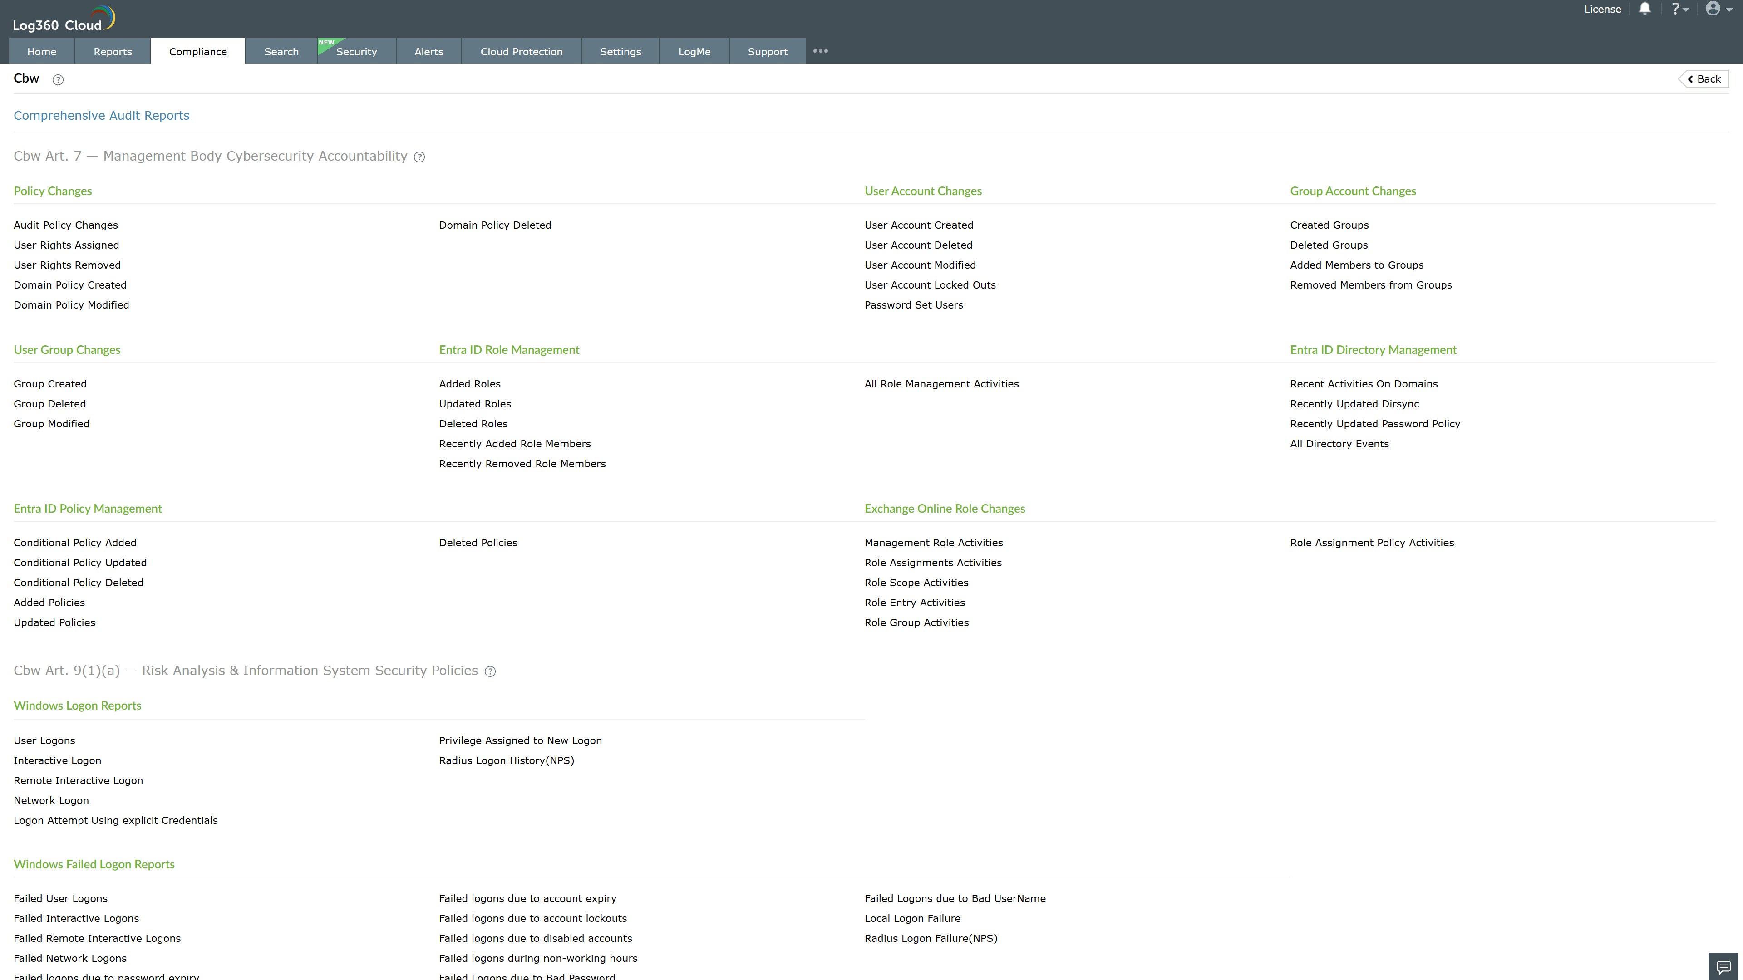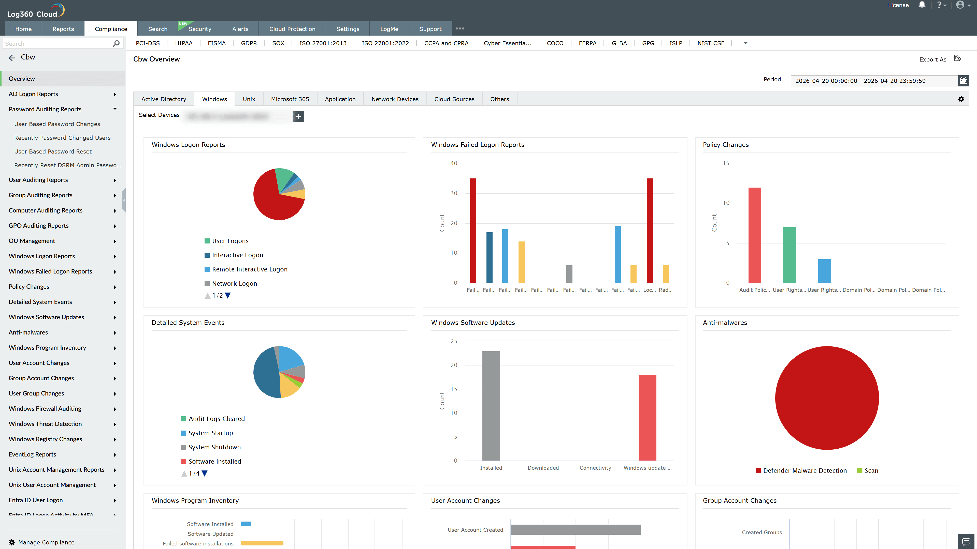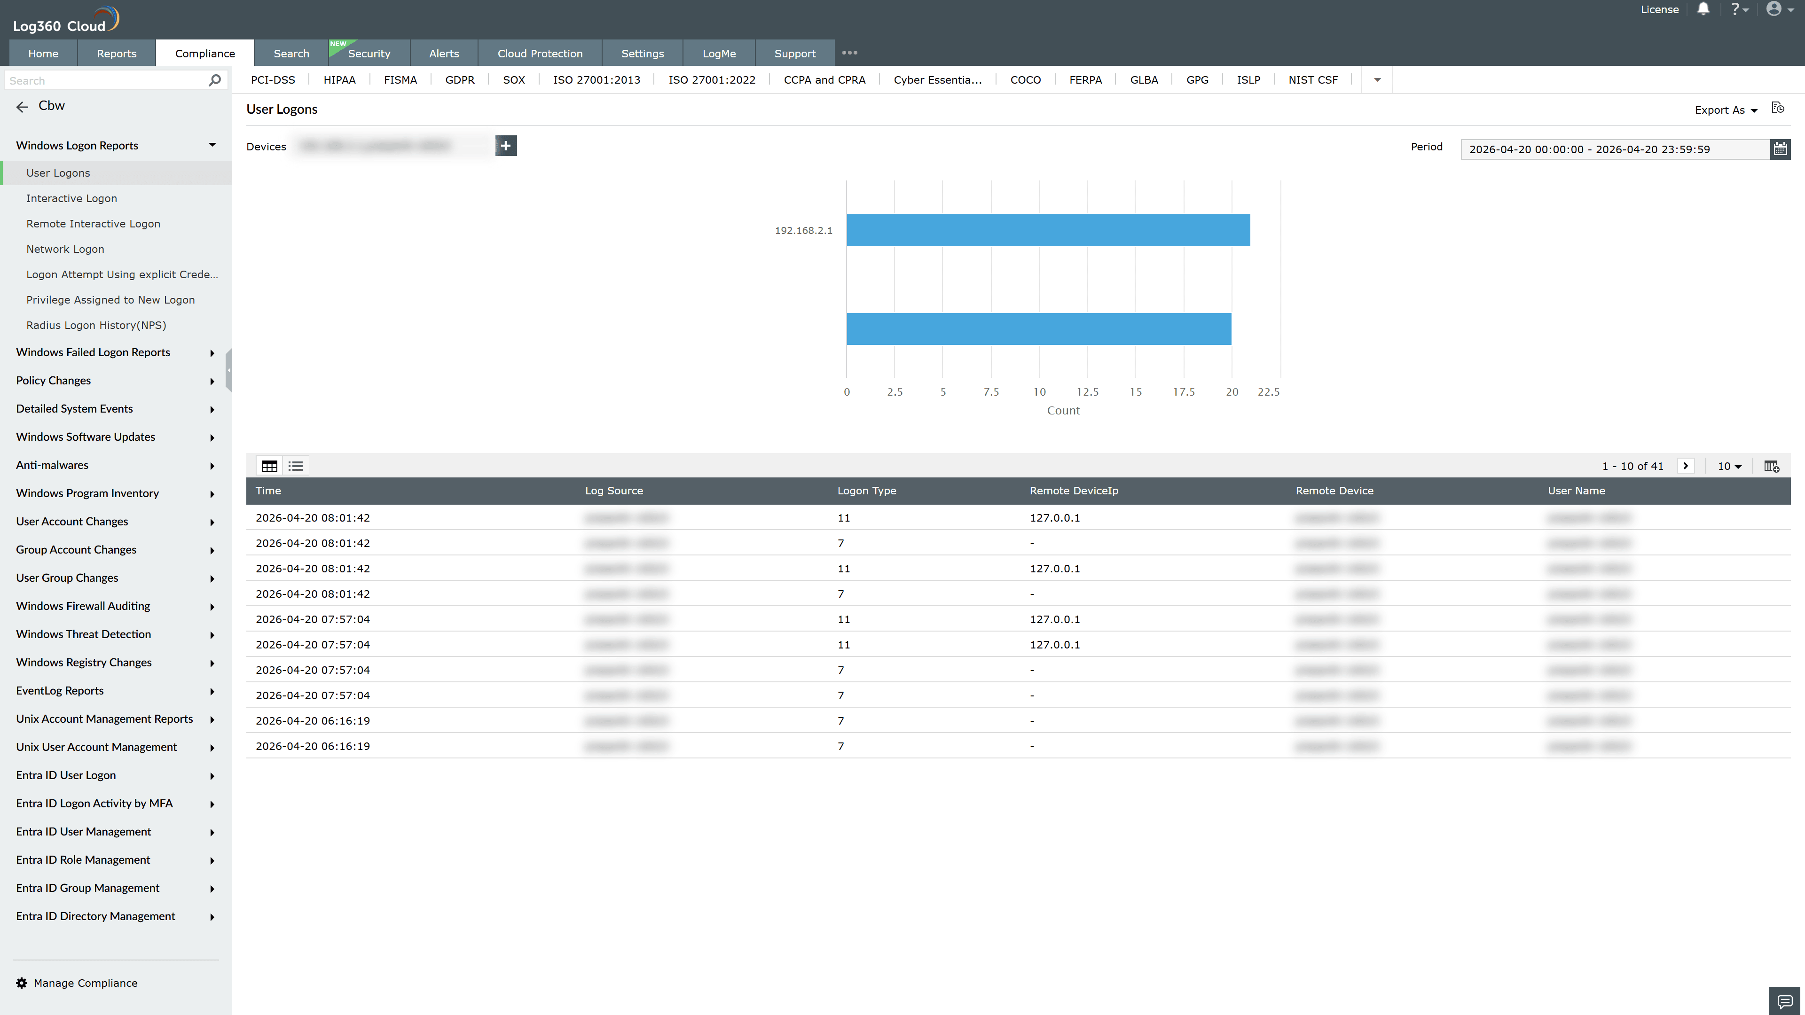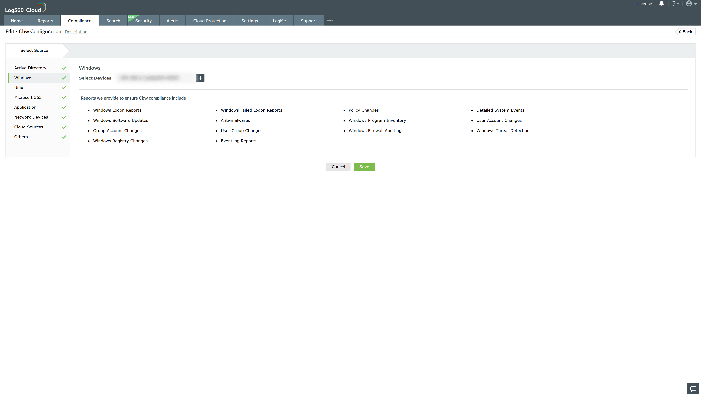

Valid Submission : Yes
Supported Editions : Free, Basic, Standard, Professional, MSSP
Help Document : https://www.manageengine.com/log-management/help/integrations/compliance-extensions.html
Help Video : Not provided
Tags : Log360, Compliance, Privacy monitoring, Data privacy, Regulatory compliance
Supported DCs : US, IN, JP, CA, AU, UK and EU
Privacy Policy:
Terms of Service:
Release Notes:
Predefined reports for the Cbw Compliance.

